Натуральний стрій
16 | 17 | 18 | 19 | 20 |  | 21 |  |  | 22 |  |  | 23 |  | 24 |  | 25 |  | 26 |  |  | 27 |  | 28 |  | 29 |  | 30 |  | 31 |  | 32
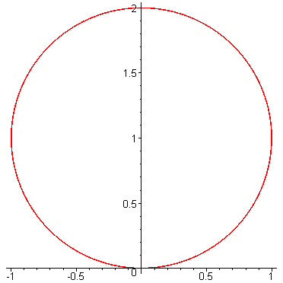 |  |  |  |  |  |  |  |  |  |  |  |  |  |  |  |  |  |  |  |  |  |  |  |  |  |  |  |  |  |  | 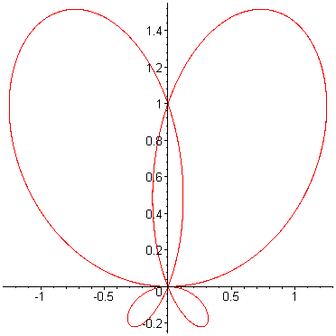
 |  |  |  |  |  |  |  |  |  |  |  |  |  | 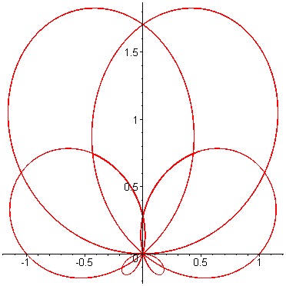
 |  |  |  | 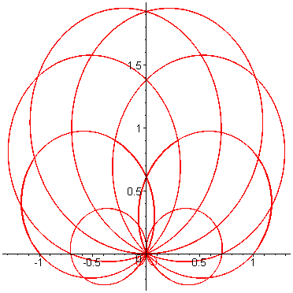 |  |  |  |  |  |  |  |  |  |  |  |  |  |  |  |  |  |  | 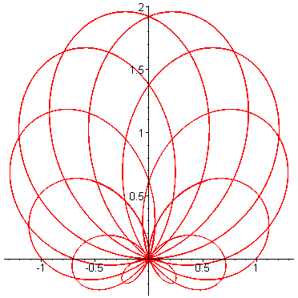
 |  | 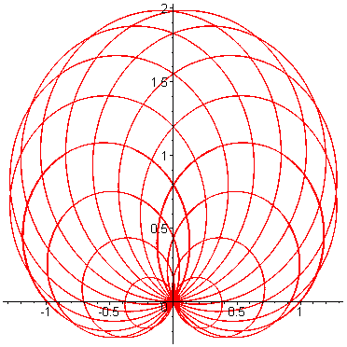 |  |  |  |  |  |  | 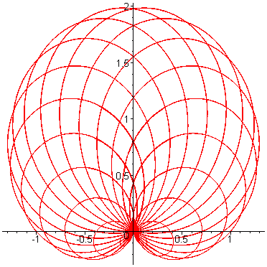 |  |  |  |  |  |  |  |  | 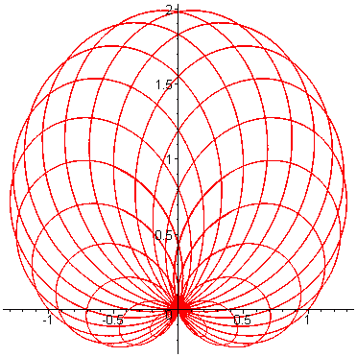 |  |  |  |  |  |  |  |  | 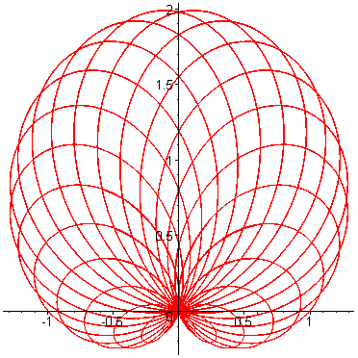
 | 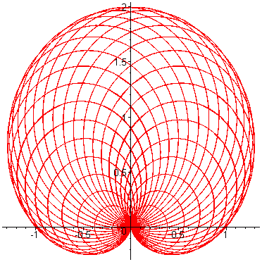 |  | 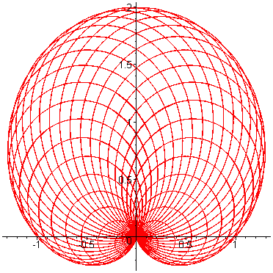 |  |  | 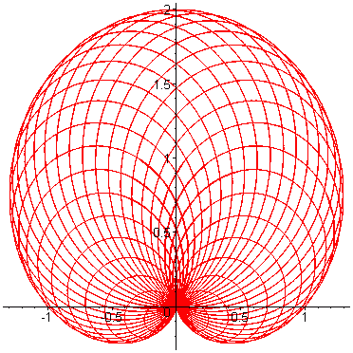 |  |  |  |  |  | 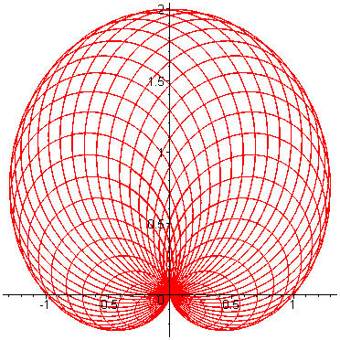 |  |  |  | 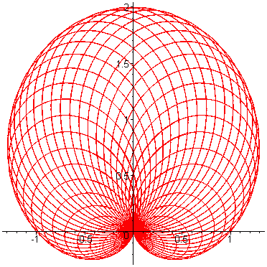 |  |  |  |  | 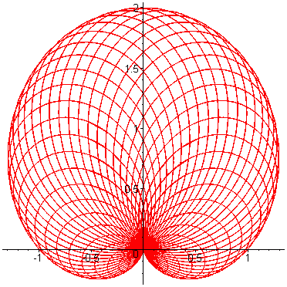 |  |  |  | 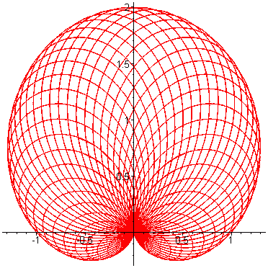 |  |  |  | 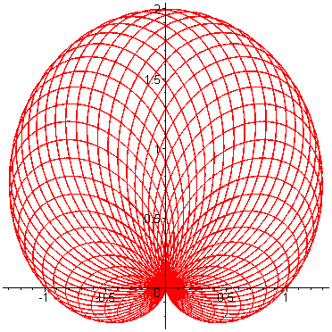
0  16  C | 1  16,95  C# | 2  17,96  D | 3  19,03  D# |  | 4  20,16  E |  |  | 5  21,36  F |  |  | 6  22,63  F# |  |  | 7  23,97  G |  |  | 8  25,40  G# |  |  | 9  26,91  A |  |  |  | 10  28,51  A# |  |  |  | 11  30,20  H |  |  | 12  32  C
 |  |  |  |  |  |  |  | 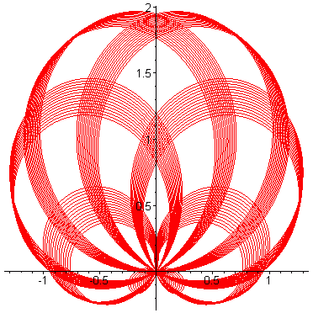 |  |  |  |  |  | 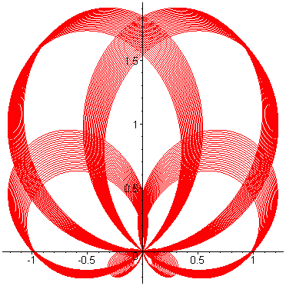 |  |  |  |  |  |  |  |  |  |  |  |  |  | 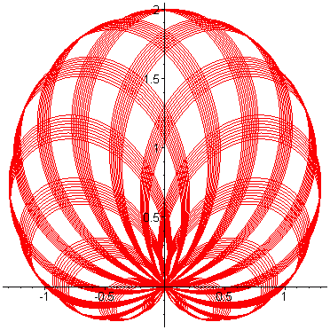
 |  |  |  |  |  |  |  |  |  |  |  |  |  |  |  |  | 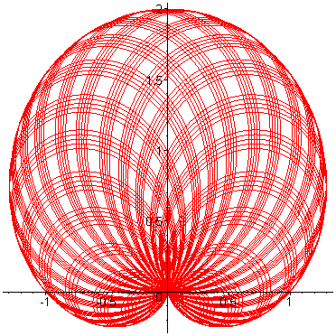
 |  | 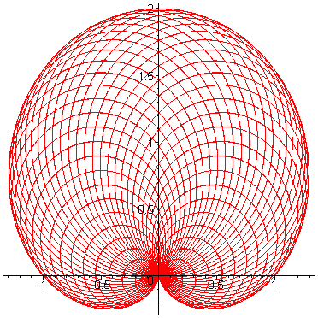 | 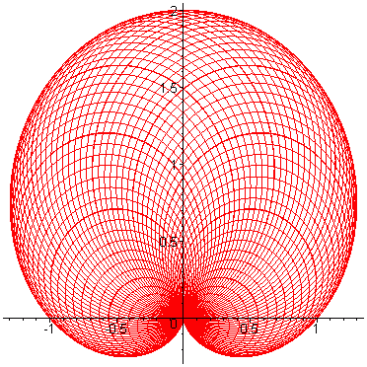 |  |  |  |  |  |  |  | 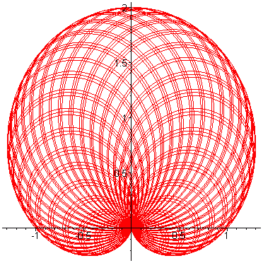 |  |  |  |  |  |  |  |  | 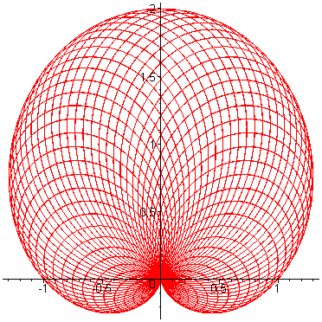
 | 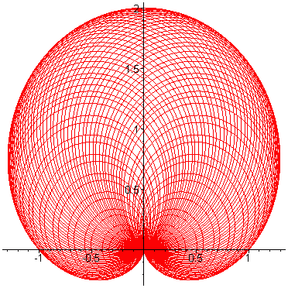 |  |  |  | 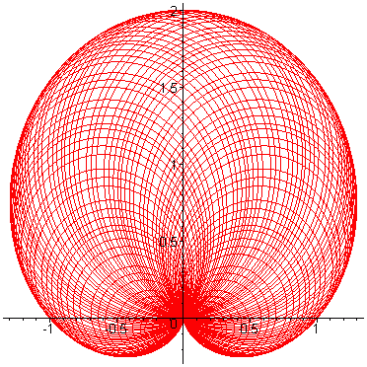 |  |  |  |  |  |  |  |  |  |  |  |  |  |  |  |  |  |  | 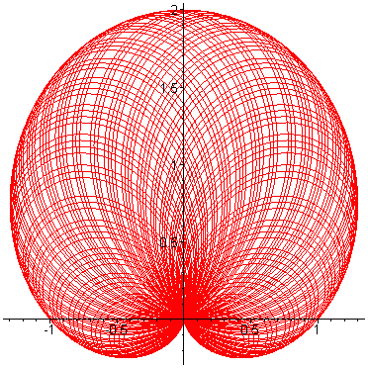
Темперований стрій

